MARI ENERGIES LIMITED · LAND MANAGEMENT SYSTEM
Demo Recording Data & Test Scenarios
As built and tested on 31 October 2026
Deliverable 5 of 5. These are the values you type during the key-features demo video.
The sequence matches the Key Features User Manual and the Demo Video Script, scene for scene. Every field, option and rule here was checked against the application's forms and database on 31 Oct 2026 (database lms_dev, migration 0059).
All people, CNICs, IBANs, phone numbers and parcel numbers below are fictional.

0. Before you record
# | Check | How
1 | The server runs the latest code | npm run build, then restart the server on port 3040. The Create acquisition button, the drawing tools and the latest fixes need this.
2 | Demo sign-in list is visible | Demo mode shows each account and its password on the sign-in page. Record on localhost, and turn demo mode off after recording (audit item O1).
3 | Map tiles load | The map needs internet (OpenStreetMap). Without it, choose Basemap None: drawing still works.
4 | Browser | Chrome, 1440 × 900 or larger, zoom 100%. Use one incognito window per user, or sign out between users.
5 | Re-authentication | Releasing a cheque asks for the password again if the sign-in is older than 10 minutes. Keep mland's password at hand.
6 | Codes | The codes in "Expected result" (e.g. REQ-2026-0004) assume nothing else is created first. If a number differs, carry on: only the number changes.
7 | Retake | If you need a second take, use the Take-2 values in §12 so you do not hit "already exists" errors.

The cast (demo accounts)
Username | Person (fictional) | Role / approval position | Province | Appears in scene
lofield | Sanaullah Khoso | Land Officer (Field) | Sindh | 1, 2, 3, 6, 7, 8
explorer | Usman Ghani | Exploration Planner | Sindh | 4, 5
dirops | Javed Akhtar | Director Operations | all | 5
regmgr | Sadia Memon | Regional Manager (Sindh) | Sindh | 5
landaffairs | Zubair Soomro | DM / TL Land Affairs | Sindh | 5
nego | Bilal Chandio | Negotiation Officer | Sindh | 7
legal | Ayesha Siddiqui | Legal Advisor | all | 7
sradmin | Faisal Shaikh | Sr. Administrator LMS (Field) | Sindh | 7
dmfield | Nadia Baig | DM / Team Lead (Field) | Sindh | 7
mland | Imran Qadir | Manager Land (HO) | all | 7, 8, 9
finance | Shazia Noor | Finance Officer | all | 8, 9

1. The story
Daharki Well-03 is a new exploratory well near Jarwar, District Ghotki, Sindh.
1. The Land Officer registers the project, two khasras and their owners (two brothers).
2. The Exploration Planner marks the land needed on the map.
3. Three approvers decide; the Regional Manager returns it once to move the boundary.
4. The Land Officer takes it up, the khasras become Under Acquisition, and an acquisition opens pre-filled.
5. A compensation case values lease, crop, trees and disturbance. Five positions approve it.
6. Finance and the Manager Land pay the first owner: WHT is deducted automatically, a cheque is released, and a receipt is printed.
7. The reports show the owner's statement and the landowner register.
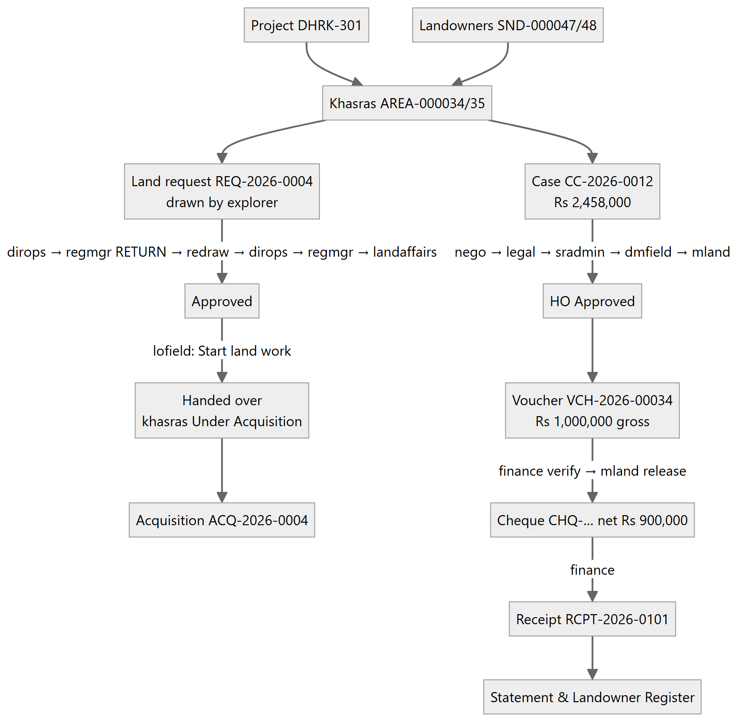

2. Scene 1: Project (user lofield)
Projects / Well Locations → + Add Project
Field | Value | Required
Project code | DHRK-301 | Yes (2–32 letters, digits, - /; unique)
Province | Sindh (SND) | Yes
Name | Daharki Well-03 Exploratory Location | Yes
Type | Well Location | Yes
Block / concession | Daharki D&PL | Yes
District | Ghotki | Yes
Required area (acres) | 20 | Optional
Description | Exploratory well pad, rig camp and 0.8 km access road north of Jarwar. Spud planned Feb 2027. | Optional

Expected result: the project DHRK-301 is listed with status Active.
The project form has no map position. The project's location comes from its khasras and its land request.

3. Scene 2: Landowners and khasras (user lofield)

3a. Landowner 1: Landowners → + Add Landowner
Field | Value | Required
Province | Sindh | Yes
CNIC | 45104-2000011-3 (type the 13 digits; dashes appear by themselves) | Yes (unique)
Full name (as on CNIC) | Ghulam Rasool Mahar | Yes
Father / husband name | Muhammad Bux Mahar | Yes
Owner type | O — Owner | Yes
Tax status | Filer | Yes (Filer → 10% WHT)
Phone | 0301-2345678 | Optional
Bank branch | HBL Daharki | Optional
IBAN | PK24HABB0012345678901234 | Optional (24 characters, format checked)
Address | Village Jarwar, Taluka Daharki, District Ghotki | Optional

Expected result: SND-000047, Active.

3b. Landowner 2: + Add Landowner
Field | Value
Province | Sindh
CNIC | 45104-2000012-1
Full name | Nazir Ahmed Mahar
Father / husband name | Muhammad Bux Mahar
Owner type | O — Owner
Tax status | Non-Filer (→ 20% WHT, shown in scene 8 option B)
Phone | 0302-3456789
Bank branch | Meezan Bank Daharki
IBAN | PK57MEZN0003450123456789
Address | Village Jarwar, Taluka Daharki, District Ghotki

Expected result: SND-000048, Active.

3c. Khasra 1: Survey / Khasra Register → + Add Survey
Field | Value | Required
Province | Sindh | Yes
Revenue location | Ghotki → Daharki → Jarwar | Yes
Project | DHRK-301 — Daharki Well-03 Exploratory Location | Optional (links the khasra to the project)
Survey / khasra no. | 451/2 | Yes
Block no. | 9 | Optional
Khasra type | Rural | Optional
Land class | Private | Yes
Recorded area | 12 with unit Acre / Killa | Yes
Latitude | 28.0710 | Optional (needed for the map)
Longitude | 69.7050 | Optional (give both or neither)
Remarks | Cultivated; tube-well on the east side. | Optional

Expected result: AREA-000034, status Proposed, area 12.00 acres.

3d. Khasra 2: + Add Survey
Field | Value
Province | Sindh
Revenue location | Ghotki → Daharki → Jarwar
Project | DHRK-301
Survey / khasra no. | 452/1
Block no. | 9
Khasra type | Rural
Land class | Private
Recorded area | 64 with unit Kanal (shows unit conversion: 64 Kanal = 8.00 acres)
Latitude | 28.0703
Longitude | 69.7062
Remarks | Wheat crop standing at the time of survey.

Expected result: AREA-000035, Proposed, 8.00 acres.

3e. Owner shares
In the Survey / Khasra Register, on the khasra's row, click Shares. Add each owner with "Landowner to add" and +, then Save shares. The total must be exactly 100%.
Khasra | Owner | Share % | Revenue document
AREA-000034 | Ghulam Rasool Mahar (SND-000047) | 60 | Fard 2026/118
AREA-000034 | Nazir Ahmed Mahar (SND-000048) | 40 | Fard 2026/118
AREA-000035 | Ghulam Rasool Mahar | 50 | Fard 2026/119
AREA-000035 | Nazir Ahmed Mahar | 50 | Fard 2026/119

Expected result: the shares column shows 100.0% and 2 owner(s).
Negative demo (optional): enter 60 + 30. The Save shares button stays disabled until the total is 100%.

4. Scene 3: The khasras on the GIS map (user lofield, optional)
GIS Land Map: the two new markers appear near Jarwar, grey (Proposed). Click one to see its code, status, area and location.

5. Scene 4: Exploration Planner draws the land (user explorer)
Sign in as explorer. The planner lands directly on the GIS Land Map: this role has no dashboard, and no Landowners or Payments menu.
1. Click ✎ Draw land request.
2. Click Paste lat/long and paste the four corners below: `` 28.07200, 69.70400 28.07200, 69.70700 28.06950, 69.70700 28.06950, 69.70400 ``
3. Click Use these corners.
4. (Optional) Click once on the map to add a fifth corner, then remove it with ×. This shows that corners can be clicked, dragged and removed.
5. Click Continue: request details.
Expected panel figures:
Item | Value
Corners | 4
Area | 20.19 acres · 8.17 ha
Centre | 28.07075, 69.70550
Parcels inside | 2: AREA-000034, AREA-000035

Land request details form:
Field | Value | Required
Project | DHRK-301 — Daharki Well-03 Exploratory Location (SND) | Yes
Purpose | Well Location | Yes
Priority | Urgent | Default Standard
Required by | 2027-01-15 | Yes
Target deh / village | Jarwar (pre-filled from the parcels inside) | Optional
Concession block | Daharki D&PL | Optional (blank = Mari Concession)
Justification | Exploratory well Daharki Well-03: well pad 120 m × 120 m, rig camp and mud pits, plus a 0.8 km access road. Rig mobilisation is planned for Feb 2027, so the land is needed by 15 Jan 2027. | Needed to submit

Click Submit to Director Operations. (Alternative: Save as draft, then submit from Land Requests → Send.)
Expected result:
- The message "Created REQ-2026-0004 and sent it to Director Operations."
- The polygon turns orange (Under review).
- Land Requests shows the workflow at step 2 and "Waiting on Director Operations".

6. Scene 5: Three-tier approval with one return
Every decision needs an Audit comment.
Step | Sign in as | Where | Action | Comment to type | Expected stage after
5.1 | dirops | Land Requests → REQ-2026-0004 → Details, then Map, then Review | Approve | Operational need confirmed: Well-03 is in the 2027 drilling plan. | Under Review - Regional
5.2 | regmgr | Land Requests → Review | Return | Pull the north boundary about 45 m south to keep clear of the Jarwar link road, then resubmit. | Returned (waiting on the initiator)
5.3 | explorer | Land Requests → Edit on map | See below | — | —
5.4 | dirops | Review | Approve | Revised boundary acceptable. | Under Review - Regional
5.5 | regmgr | Review | Approve | Region supports it; no conflict with other activity. | Under Review - Land Affairs
5.6 | landaffairs | Review | Approve | Private land, two owners identified, no litigation recorded. Approved. | Approved (green)

Step 5.3, the redraw by explorer:
1. Click Clear, then Paste lat/long, and paste the revised corners below. Then Use these corners. `` 28.07160, 69.70400 28.07160, 69.70680 28.06950, 69.70680 28.06950, 69.70400 `` Expected: 15.83 acres · 6.41 ha, still 2 parcels inside.
2. Click Continue: review and save.
3. In What changed, type: North boundary moved 45 m south and east edge 20 m west, as asked by the Regional Manager.
4. Click Save and send to Director Operations.
Expected: the stage goes back to Submitted, and Details → Polygon versions lists v2 (current) and v1.
Negative checks you can show:
- regmgr gets no Review button while the request waits for Director Operations.
- explorer cannot approve their own request.
- In 5.4, dirops decides again: after a return, every tier decides afresh.

7. Scene 6: Hand-over and acquisition (user lofield)
1. Land Requests → REQ-2026-0004 → Start land work.
Field | Value
Land work | Acquisition
Mark the recorded parcels inside the polygon "Under Acquisition" | ✔ (ticked)
Comment | Negotiation with the Mahar family starts 10 Nov 2026.

Click Take it up.
Expected result:
- "REQ-2026-0004 handed over for acquisition. 2 parcel(s) marked Under Acquisition: AREA-000034, AREA-000035."
- The stage is Handed over (blue on the map).
- Both khasras are now Under Acquisition in the Survey register.
1. On the same row, click Create acquisition. The form "Add Acquisition — from REQ-2026-0004" opens pre-filled:
Field | Pre-filled / enter | Required
Project | DHRK-301 (pre-filled) | Yes
Mode | Private Lease | Yes
Area required | 15.83 (pre-filled from the polygon) | Yes
Negotiated rate (Rs / acre) | 60000 | Optional
Target handover | 2027-01-15 (pre-filled) | Optional
Surveys | AREA-000034, AREA-000035 (pre-filled chips) | Optional
Remarks | From land request REQ-2026-0004 (Well Location). (pre-filled) | Optional

Click Save.
Expected result:
- ACQ-2026-0004 is created at stage Identification.
- Land Requests → Details shows "record ACQ-2026-0004".
1. (Optional) Click Title and tick:
- Fard / Record of Rights
- Latest mutation verified
- CNIC of every owner verified
Each tick records who and when.

8. Scene 7: Compensation case and its approval chain

8a. Create the case (user lofield)
Compensation Cases → + Add Compensation Case
Header:
Field | Value | Required
Project / well location | DHRK-301 | Yes
Land used for | Well Location | Yes
Lease rate (Rs / acre / year) | 60000 | Required when there are lease lines
Lease term (months) | 36 | Required when there are lease lines
Remarks | Three-year surface lease for the Well-03 pad, with crop and tree damage. | Optional

Landowners (+ Add line). The shares must total 100%.
Landowner | Share % | As
Ghulam Rasool Mahar (SND-000047) | 60 | O — Owner
Nazir Ahmed Mahar (SND-000048) | 40 | O — Owner

Lease lines
Survey | Owners' share % | Area (ac) | Reduced area (ac)
AREA-000034 | 100 | 12 | (blank)

Crop compensation
Survey | Crop | Rate (Rs/ac) | Damaged (ac)
AREA-000035 | Wheat | 45000 | 5

Tree compensation
Survey | Species | Size | Rate (Rs) | Count
AREA-000035 | Kikar | Medium | 8000 | 6

Other compensation
Survey | For | Amount (Rs)
AREA-000034 | Disturbance allowance | 25000

Documents seen: tick all six:
1. CNIC copies of all landowners
2. Fard / record of rights
3. Signed consent / agreement
4. Bank details or IBAN certificate
5. Site photographs
6. Joint survey / measurement report
Click Create case.
Expected amounts (calculated by the database, not typed):
Head | Calculation | Amount (Rs)
Lease | 60,000 × 12 ac × 36 ÷ 12 | 2,160,000
Crop | 45,000 × 5 ac | 225,000
Trees | 8,000 × 6 | 48,000
Other | — | 25,000
Total award |  | 2,458,000

Expected result:
- CC-2026-0012, stage Prepared.
- lofield sees no approve button: the preparer cannot approve.

8b. Approval chain: one person, one step
Open the case and use the workflow button. A note is optional, but say it aloud.
Step | Sign in as | Button | Note | Stage after
1 | nego | → Checked | Rates agreed with both owners on site. | Checked
2 | legal | → Reviewed | Title clear per Fard 2026/118–119; no litigation. | Reviewed
3 | sradmin | → Verified | Field records and measurements verified. | Verified
4 | dmfield | → Field Approved | Approved at field level. | Field Approved
5 | mland | → HO Approved | Approved at head office. | HO Approved (locked)

Negative checks:
- nego cannot approve two steps; the second attempt is refused.
- Step 4 is refused if a required document is unticked, with "Missing documents: …".

9. Scene 8: Payment, WHT, cheque and receipt

9a. Request the voucher (user lofield)
Payments & Cheques → + Request Payment
Field | Value | Required
Project | DHRK-301 | Yes
Case | CC-2026-0012 · Rs 2,458,000 outstanding | Optional (only HO Approved cases are listed)
Payee (landowner) | Ghulam Rasool Mahar — Filer | Required when a case is chosen
Category | Lease Rent | Yes
Pay type | Advance Lease (multi-year) | Yes
Payment mode | Cross Cheque | Yes
Land class | Private | Yes
Period from | 2026-11-01 | Yes
Period to | 2029-10-31 | Optional (on or after the start)
Gross amount (Rs) | 1000000 | Yes
Remarks | First instalment: advance lease rent for the Well-03 pad (60% owner). | Optional

Expected result:
- VCH-2026-00034, stage Requested.
- WHT 10% = Rs 100,000; net Rs 900,000. The rate is set by the system from the owner's Filer status.
Option B (shows the non-filer rate): a second voucher for Nazir Ahmed Mahar: category Crop Compensation, pay type One-time, mode Direct Credit (IBFT), gross 500000.
- Expected WHT is 20% = Rs 100,000; net Rs 400,000.
Negative checks:
- Gross 2500000: refused, "case CC-2026-0012 award is 2458000.00 … at most … can still be requested".
- A typed payee name instead of an owner: refused.

9b. Verify (user finance)
Payments → Vouchers → VCH-2026-00034 → Verify. Note: Payee, WHT and case checked.
Expected result: stage Verified. The budget check runs here.

9c. Release the cheque (user mland)
Payments → VCH-2026-00034 → Release cheque.
Field | Value
Cheque date | 2026-11-05 (or today)
Note | Released to the owner at Daharki field office.

If asked, re-enter mland's password.
Expected result:
- Stage Released; cheque CHQ-25186412 for Rs 900,000 (net).
- A SAP posting is queued.

9d. Record and print the receipt (user finance)
Payments → Cheques tab → CHQ-25186412 → Record receipt.
Field | Value | Required
Receipt no. | RCPT-2026-0101 | Yes
Received on | 2026-11-05 | Yes
Acknowledged by | Ghulam Rasool Mahar | Yes
Their CNIC | 45104-2000011-3 | Optional
Remarks | Cheque received in person. | Optional

Then click Print receipt in the Receipts table.
Expected result: a printable Receipt of Payment showing:
- the parcel (Survey 451/2, Deh Jarwar, Taluka Daharki, District Ghotki)
- the heads
- Gross 1,000,000; less WHT (Filer) 100,000; Total 900,000
- the amount in words
- the settlement (payable to this owner, paid before, this payment, balance)
- the declaration and signature blocks

9e. Allocate to the case (user lofield or finance, optional)
Payments → Liabilities tab → CC-2026-0012 → Allocate voucher:
- Voucher: VCH-2026-00034
- Amount: 900000 (the net amount)
Expected result: the case shows Part paid, and Ghulam Rasool Mahar's statement balance falls by the allocated amount.

10. Scene 9: Reports and dashboard
Step | Sign in as | Where | What to show | Expected
10.1 | lofield | Landowners → SND-000047 → Statement | Owed, paid, balance; payment lines gross with WHT in the description | The award share and Rs 1,000,000 paid (900,000 cheque + 100,000 WHT)
10.2 | mland | Records & Reports → Landowner Register | Province Sindh, District Ghotki, Taluka Daharki, Deh Jarwar; Area unit All in Kanal; Show One row per owner | Ghulam Rasool Mahar and Nazir Ahmed Mahar with their khasras and shares; 12 ac = 96 Kanal, 8 ac = 64 Kanal
10.3 | mland | Export buttons PDF / Excel / CSV | Download | The file has the same rows as the screen
10.4 | mland | Executive Dashboard | Province chart, paid vs approved, approvals waiting | Figures include the new case and cheque
10.5 | audit | Audit Trail | Filter by record REQ-2026-0004 or CC-2026-0012 | Every change, with who and when

11. Validation scenarios (quick "what if" shots)
# | Scenario | Where / who | Input | Expected message / result
V1 | Boundary crosses itself | GIS draw (explorer) | Paste 28.0720, 69.7040 / 28.0695, 69.7070 / 28.0720, 69.7070 / 28.0695, 69.7040 | "The boundary crosses itself…"; Continue disabled
V2 | Corner outside Pakistan | GIS draw | 50.0, 10.0 as one corner | "Every corner must be inside Pakistan…"
V3 | Shares ≠ 100% | Shares dialog | 60 + 30 | Save disabled
V4 | Duplicate CNIC | Add Landowner | 45104-2000011-3 again | "A landowner with this CNIC is already registered"
V5 | Preparer approves own case | lofield on CC-2026-0012 | — | No approve button
V6 | Over-award voucher | Request Payment | Gross 2500000 on CC-2026-0012 | Refused; "at most … can still be requested"
V7 | Province isolation | loquetta (Balochistan) | Open Land Requests | REQ-2026-0004 is not listed
V8 | Planner sees no owner data | explorer | Menu | No Landowners / Payments / Cases; the Survey register has no Shares button

12. Take-2 values (for a second recording)
Use these if the first take's records already exist. All rules are the same.
Item | Take-2 value
Project code / name | DHRK-302 / Daharki Well-04 Exploratory Location
Landowner 1 | CNIC 45104-2000021-7, Abdul Sattar Lund, father Haji Karim Bux Lund, Filer, IBAN PK11UNIL0109000300123456
Landowner 2 | CNIC 45104-2000022-5, Shabbir Ahmed Lund, father Haji Karim Bux Lund, Non-Filer
Khasra 1 | 461/3, block 10, 12 Acre, lat 28.0810 lng 69.7350
Khasra 2 | 462/1, block 10, 64 Kanal, lat 28.0803 lng 69.7362
Polygon v1 | 28.08200, 69.73400 / 28.08200, 69.73700 / 28.07950, 69.73700 / 28.07950, 69.73400
Polygon v2 | 28.08160, 69.73400 / 28.08160, 69.73680 / 28.07950, 69.73680 / 28.07950, 69.73400
Receipt no. | RCPT-2026-0102

Areas are about the same as take 1. These coordinates are clear of every existing request and of the Disputed parcel AREA-000011 (28.090, 69.720).

